CHAPTER 1 – EXPLORING AND CLASSIFYING LIVING THINGS

SECTION 1- WHAT IS SCIENCE?

Scientific Method: A series of procedures used in science.
- State the Problem- this is the title of experiment in the form of a question.
- Gather Information- using previous knowledge by observing.
- Form a Hypothesis- this is a prediction that can be tested.
- Procedure (experiment) – Testing the Hypothesis
  - Control- the standard, to which the outcome of a test is compared, always stays the same.
  - Variable- something in an experiment that can change, an experiment should have only one variable.
- Data (graphs/tables)- information collected during the experiment, used to accept or reject the hypothesis.
- Conclusion- Giving evidence on why you accept or reject the hypothesis.
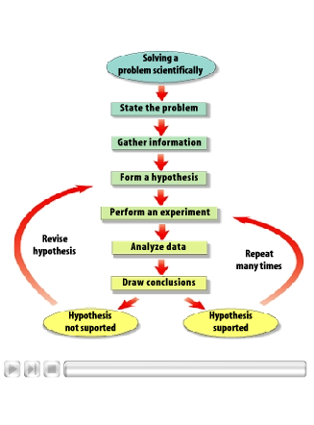

Scientific Theory: an explanation of things or events based on scientific knowledge that is the result of many observations and experiments.

Scientific Laws: a statement about how things work in nature that seems to be true all the time.

International System of Units or SI: standard system of measurement scientist use to communicate and understand each other’s research and results.



