CHAPTER 2- CELLS
SECTION 1- CELL STRUCTURE

COMMON CELL TRAITS
* Cell is the smallest unit that is capable of performing life functions.

Cell Membrane
Cells outer covering.

Cytoplasm
Gelatinlike material in a cell that contains the hereditary material that controls the life of the cell.
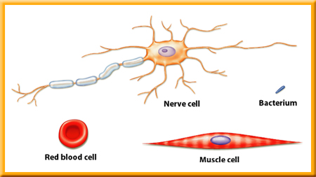
Comparing Cells

Nerve cells can be a meter long

8,000 of the smallest bacterium can fit in a red blood cell

A human egg cell is no bigger than the dot on an i, a blood cell is one tenth the size of a human egg cell.

*Nerve cells have fine extensions that send and receive impulses to and from cells.
*Muscle cells and some blood cells can change shape
*Plant stems have long and hollow cells with opening at their end, the carry food and water throughout the plant.

EUDARYOTIC
Cells with membrane-bound structures

PRODARYOTIC
Cells without membrane-bound structures

CELL ORGANIZATION

Cell Walls
*Tough, rigid outer coverings that protect the cell and give it shape
*Cellulose- a carbohydrate that makes up most plant cell walls
*Pectin- also in cell walls- used in jelly and jam
*Lignin- compound found in cell walls that make them rigid. Plant cells responsible for support have a lot of lignin their walls.

CELL MEMBRANE
*protective layer around all cells
*if a cell has a cell wall the membrane is inside of it.
*regulates interaction between the cell and the environment

CYTOPLASM
*gelatinlike substance that fills the cell
*cytoskeleton- a framework throughout the cytoplasm that maintains or changes its shape, made of thin hollow tubes of protein and solid protein fibers.
*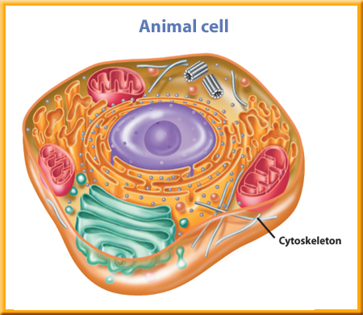

ORGANELLES- the “organs” of the cell, found in eukaryotic cells, some process energy and other manufacture substances needed by the cell. Most organelles are surrounded by membranes. The NUCLEUS is the largest organelle.

NUCLEUS
- Directs all cell activities “the brain of the cell” contains instructions for everything the cell does.
- DNA
  - Found in the nucleus
  - Threadlike fibers with instructions material on them
  - Contains the code for cell’s structure and activities.
- Nucleolus is found in the nucleus.

ENERGY- PROCESSING ORGANELLES
Chloroplasts
*In plant cells, food is made in green organelles in the cytoplasm, contain green pigment chlorophyll, makes plants green.
*Glucose- Chlorophyll captures light energy that is used to make sugar
*Animals do not have chloroplasts for making food- we eat.

MITOCHONDRIA
Organelles where energy is released from breaking down food into carbon dioxide and water.

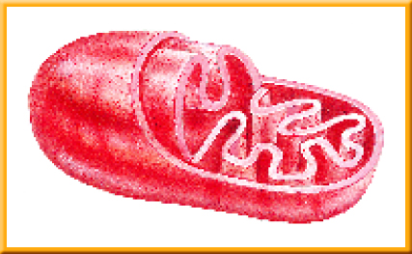

MANUFACTURING ORGANELLES
*Ribosomes-
* were protein is made.
*some float freely in the cytoplasm, others are attached to endoplasmic reticulum.
* receive direction from hereditary material- how, when, and in what order to make certain protein.

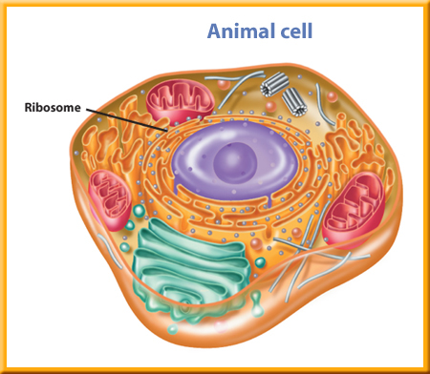

PROCESSING, TRANSPORTING, AND STORING ORGANELLES

*Endoplasmic reticulum (ER)
* extends from the nucleus to the cell membrane
*series of folded membranes in materials can be processed and moved
around inside of cell- transports materials
*can be rough or smooth
* if no ribosomes are attached they are “smooth endoplasmic reticulum- this type produces lipids that store energy
* Rough endoplasmic reticulum have ribosomes ( make protein) attached
*Golgi Bodies- take proteins, package them into membrane bound structures call vesicles- they transport cellular substances inside outside of the cell.
*Vacuole-storage area for water, waste products, food, and other cellular materials

RECYCLING ORGANELLES

*Lysosomes- Garbage Area
* contain digestive chemicals that help break down food molecules,
cell waste, and worn-out cell parts.
*when a cell dies, lysosome’s membrane disintegrates, releases
Digestive chemicals that breakdown the cell’s content.

FORM CELL TO ORGANISM

*Tissue-
*group of similar cells that work together to do one job
*tissues are organized into organs
*Organ
*is a structure made up of two or more different types of tissue
that work together
*Organ Systems
*group of organs working together to perform a certain function



